ANALYSIS OF CANDID LOCATION FOR STARTING NEW STORES AT NEW JERSEY

Khandavilli Ramya Geethika

November 4, 2019

2. DATA ACQUISITION AND CLEANING:

2.1 Data sources

As per the requirement, in order to meet the conditions and solve the business problem, first we need the data for New Jersey state top 10 cities by population. Second, need the venues/business point information for the gathered cities and neighborhoods.

Data was gathered from various websites from internet for analysis.
https://en.wikipedia.org/wiki/New_Jersey
http://www.city-data.com/city/New-Jersey.html
https://www.geonames.org/US/NJ/largest-cities-in-new-jersey.html
https://en.wikipedia.org/wiki/List_of_neighborhoods_in_Newark,_New_Jersey

2.2 Data cleaning

Data downloaded or scraped from multiple sources were inserted into couple of tables. There are several problems with the data sets. First, we could not find the exact data that we are looking for.
Had to use various sources to gather the required data. From city-data website could find the major cities ( where population greater than 6000) in New Jersey state. Got total count of 571 cities which met this criteria. By sorting descending by population, could find top 10 cities by population in New Jersey.

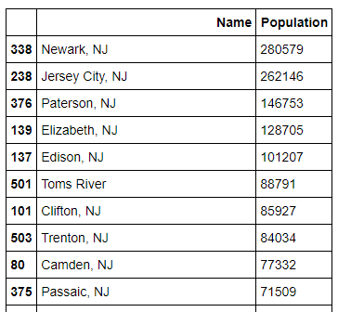

Second, need to find these top ten cities geo coordinates. For this had to scrap data from geonames.org web site. It has latitude and longitude information of top 10 cities in NJ state in a single column. After inserting data into data frame had to clean the data for formatting and split the lat/lang column to separate columns. I have dropped the unwanted columns from these data sets.

After fixing these problems, I checked for outliers in the data. I found that the data looks clean now as per our requirement to start the analysis.

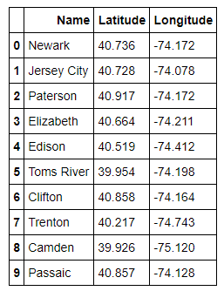
Using this top 10 cities information, by utilizing the FourSquare api got top venues/businesses information for these cities. Upon further analysis, explored the suggested city venues information for the point of interest.

Using wikipedia page on Newark city’s neighborhoods, derived NewarkNhb.csv contains below data.
This data has been used for further analysis on Newarks neighborhood’s venues/business points.

